**Implementing JWT with Spring Security in Spring Boot Application**

**1.Code for implementing Spring Security:**

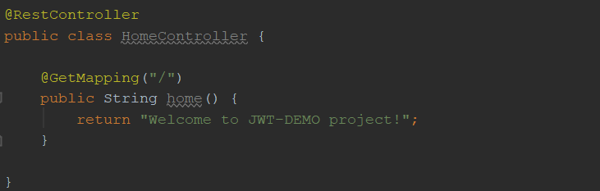

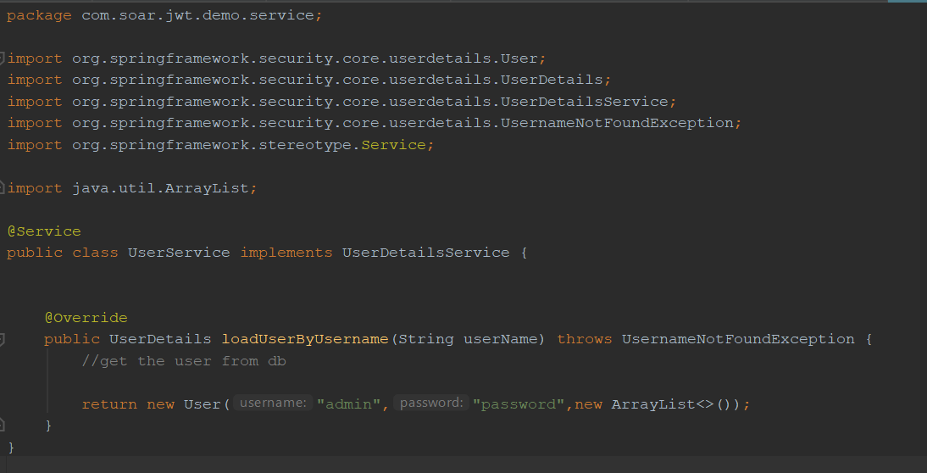

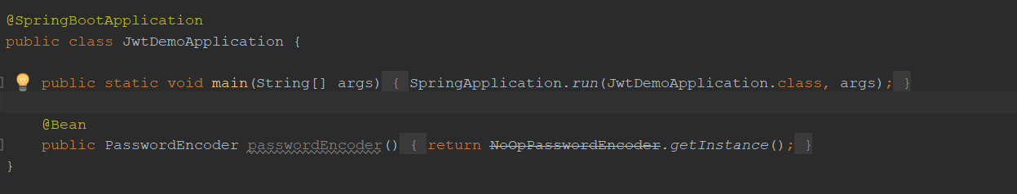

@Configuration  
@EnableWebSecurity  
public class SecurityConfiguration extends WebSecurityConfigurerAdapter {  
  
 @Autowired  
 private UserService userService;  
  
 @Override  
 protected void configure(AuthenticationManagerBuilder auth) throws Exception {  
 auth.userDetailsService(userService);  
 }

}

**Create application.yml:**

**server**:  
 **port**: 8083

**Test Spring Security before implementing JWT functionality:**

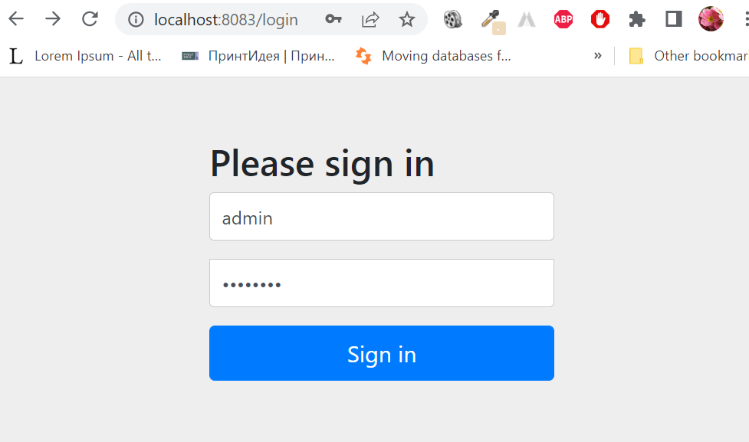

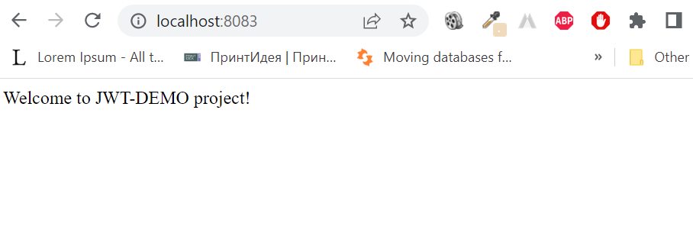

**2. Add dependencies for JWP in pom.xml:**

<dependency>  
 <groupId>io.jsonwebtoken</groupId>  
 <artifactId>jjwt</artifactId>  
 <version>0.9.1</version>  
</dependency>  
<dependency>  
 <groupId>javax.xml.bind</groupId>  
 <artifactId>jaxb-api</artifactId>  
</dependency>

**Create packages and classes for implementing JWT functionality:**

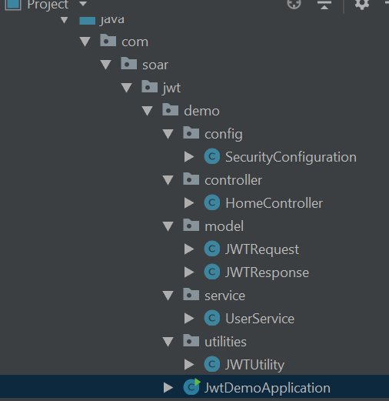

**Make some changes to application.yml:**

**server**:  
 **port**: 8083  
  
**jwt**:  
 **secret**: secretkey123

**The code is in** [**https://github.com/soniaarnaudova/jwt-springsecurity-springboot**](https://github.com/soniaarnaudova/jwt-springsecurity-springboot)

**Test with Postman:**

